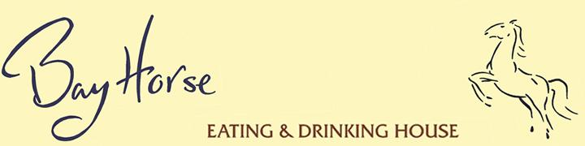
New Year’s Eve
A little cup of butternut squash soup with truffle & pumpkin seed oil
O0O
Seafood plate of marinated west coast scallops, dill & whisky mustard cured salmon, Port of Lancaster beech wood smoked salmon – crab & shrimp cocktail, served with beetroot and horseradish relish & cucumber pickle
Goats cheese & herb terrine with walnuts, watercress & port poached pear
Pressing of Goosnargh duckling, pickled wild-mushrooms & damson sauce

O0O

Champagne sorbet

O0O

Roast fillet of Cumbrian beef, braised shin of beef, horseradish mashed potato, baked tomato, grilled Portobello mushroom, rich ale juices
Fillet of halibut, crushed potatoes with lobster, cucumber, tomato & spiced shellfish sauce
Pressed potatoes, wild- mushrooms, spinach, poached duck egg, red wine dressing

O0O

Dessert plate: chocolate & orange tart, lemon posset, sticky toffee pudding, peanut butter ice cream, baked apple with honey & raisins

O0O

Port soaked Garstang Blue cheese & creamy Lancashire cheese with oatcakes and pear chutney

O0O

Coffee & chocolates

£65.00 per person (£32.50 for children under 12)
50% deposit at time of booking &
remaining balance to be paid by 4th December

Christmas Day Lunch

Bucks fizz reception

O0O

A little cup of celeriac soup with truffle & chestnuts

O0O

Pot of Lancaster beech wood smoked salmon, dill cured salmon, potted salmon, crab and shrimp cocktail, pickled cucumber & salmon caviar

O0O

Mulled wine sorbet

O0O

Roast Goosnargh corn-fed turkey, spiced Cumbrian ham hock, locally reared roast goose, bread sauce, cranberry relish, game chips, brandy roasting juices, duck fat roast potatoes & seasonal vegetables
(vegetarian alternative on request)

O0O

Festive dessert plate: chocolate & orange tart, Christmas pudding with rum sauce, Christmas pudding ice cream & mum’s sherry trifle

O0O

Port soaked Garstang Blue cheese & creamy Lancashire cheese with oatcakes and pear chutney

O0O

Coffee & chocolates

£75.00 per person (£37.50 for children under 12)
Minimum of 4 persons
50% deposit at time of booking &
remaining balance to be paid by 27th November

Party Menu

Parsnip and roast garlic soup
Plate of Port of Lancaster beech smoked salmon, traditionally garnished
Trough of Bowland game terrine with pickled wild mushrooms, red wine prunes & truffle dressing

O0O

Roast sirloin of Cumbrian beef, roast potatoes, potato puree, horseradish sauce, thyme Yorkshire pudding & red wine gravy
Roast breast of Goosnargh corn-fed chicken, smoked bacon mashed potato, herb and goats cheese butter
Salmon fillet, crushed potatoes, warm spiced potted shrimps
Pressed potatoes, wild-mushrooms, spinach, poached duck egg & red wine dressing

O0O

Chocolate pot, marmalade ice cream and boozy orange segments
Sticky toffee pudding with vanilla ice cream
Port soaked Garstang Blue cheese and creamy Lancashire cheese with oat cakes and pear chutney

O0O

Coffee & chocolates

£27.50 per person (£13.75 for children under 12)
Minimum of 8 persons
50% deposit at time of booking

Menu pre order required 7 days prior to reservation

The Bay Horse Inn, Bay Horse, Ellel, Lancaster LA2 0HR 01524 791204 www.bayhorseinn.com yvonne@bayhorseinn.com

